SPAN. 201.04 – Intermediate Spanish
GUÍA DE ANÁLISIS DE LA PELÍCULA ROMA, DE ALFONSO CUARÓN
- Describe en general la casa donde vive la familia protagonista. Describe una de las habitaciones.
________________________________________________________________________________________________________________________________________________________________________________________________________________________________________________________________________________________________________________________________________________________________________________________________________________________________________________________________________________________________________________________________________________________________________________________________________________________________________________________________________________________________________
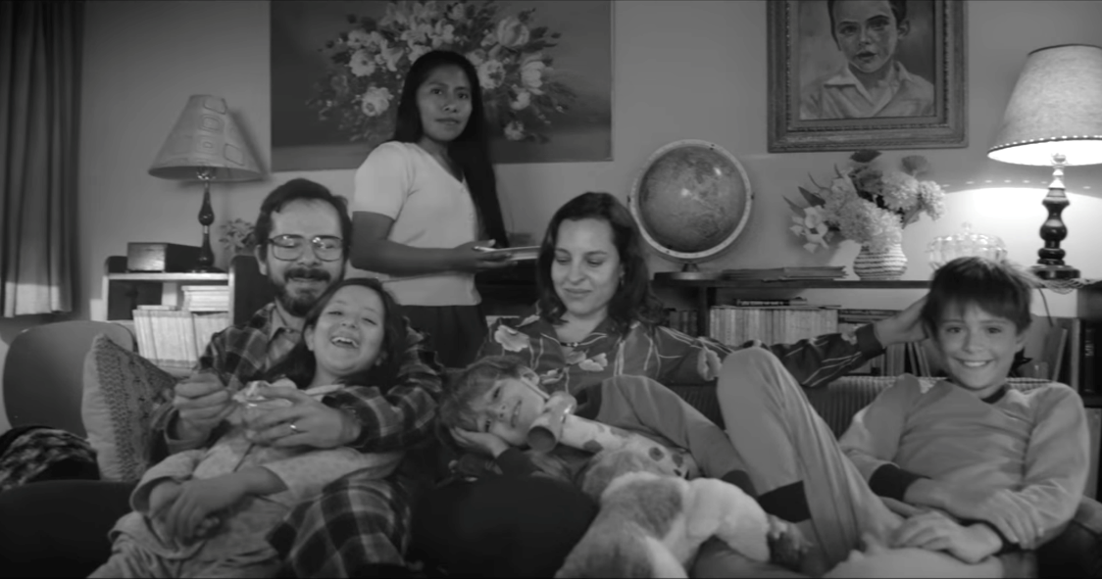

- Describe el carácter y la personalidad de DOS personajes. Usa alguno de estos adjetivos:
TRABAJADOR/A DÉBIL CRUEL DELICADO/A SUMISO/A DULCE PACIENTE MATERNAL VALIENTE AUTORITARIO MACHISTA FEMINISTA REBELDE SOÑADOR/A BRUTAL LUCHADOR/A INDEPENDIENTE CARIÑOSO/A FRÍO/A SENSIBLE SENSATO PEREZOSO/A TRISTE CONTENTO/A
_________________________________________________________________________________________________________________________________________________________________________________________________________________________________________________________________________________________________________________________________________________________________________________________________________________________________________________________________________________________________________________________________________________________________________________________________________________________________________________________________________________________________________________________________________________________________________________________________________________________________________________________________________________________________________________________________________________________________________________________________________________________________________________________________________________________________________________________________________________
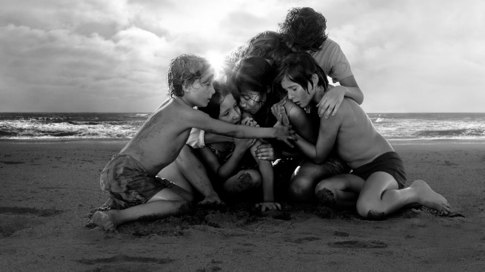
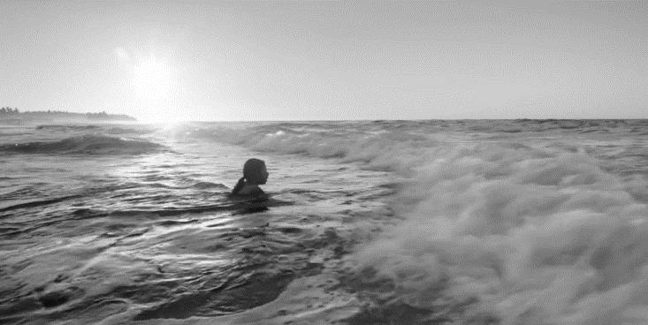

- Describe (brevemente) la secuencia de la playa hacia el final de la película utilizando los distintos past tenses (Preterite, Imperfect, Present Perfect)
________________________________________________________________________________________________________________________________________________________________________________________________________________________________________________________________________________________________________________________________________________________________________________________________________________________________________________________________________________________________________________________________________________________________________________________________________________________________________________________________________________________________________________________________________________________________________________________________________________________________________________________________________________________________________________________________________________________________________________________________________________________________________________________________________________________________________________________________________________________________________________________________________________________________________________________________________________________________________________________________________________________________________________________________________________________________________________________________________________________________________________________________________________________________________________________________________________________________________________________________________________________________________________________________________________________________________________________________________________________________________________________________________________________________________________________
- Escribe tu crítica de la película ¿Te ha gustado? ¿Por qué?
__________________________________________________________________________________________________________________________________________________________________________________________________________________________________________________________________________________________________________________________________________________________________________________________________________________________________________________________________________________________________________________________________________________________________________________________________________________________________________________________________________________________________________________________________________________________________________________________________________________________________________________________________________________
- ANSWER IN ENGLISH What are the class, race, and gender issues addressed in the movie?
______________________________________________________________________________________________________________________________________________________________________________________________________________________________________________________________________________________________________________________________________________________________________________________________________________________________________________________________________________________________________________________________________________________________________________________________________________________________________________________________________________________________________________________________________________________________________________________________________________________________________________________________________________________________________________________________________________________________________________________________________________________________________________________________________________________________________________________________________________________________________________________________________________________________________________________________________________________________________________________________________________________________________________________________________________________________________________________________________________________________________________________________________________________________________________________________________________________
- ANSWER IN ENGLISH In which ways the story can still be relevant today?
______________________________________________________________________________________________________________________________________________________________________________________________________________________________________________________________________________________________________________________________________________________________________________________________________________________________________________________________________________________________________________________________________________________________________________________________________________________________________________________________________________________________________________________________________________________________________________________________________________________________________________________________________________________________________________________________________________________________________________________________________________________________________________________________________________________________________________________________________________________________________________________________________________________________________________________________________________________________________________________________________________________________________________________________________________________________________________________________________________________________________________________________________________________________________________________________________________________________________________________________________________________________________________________________________________________________________________________________________________________________________________________________________________________________________________________________________________________________

